AI Use Declaration Form
Course: Introduction to Artificial Intelligence
Lab Title: Lab 1
Student Name: Maame Aba Kwofie
Student ID: 32952028
GitHub Repository Link: https://github.com/abakwofie/Kwofie_Maame_Lab1.git
Date Submitted: 20th June 2026

1. AI Use Summary
Question | Student Response
Did you use any AI tool for this lab? | Yes
Estimated percentage of the work influenced by AI | 5%
Did you attach evidence of AI use where applicable?

2. Details of AI Use
Complete the table below for each AI tool used. Add more rows where necessary.
Name of AI Tool Used | Purpose for Using the Tool | Prompt or Instruction Given to the Tool | Part(s) of the Work Influenced by the Tool | How I Verified, Edited, or Improved the AI Output
Gemini | To get clarification on how to implement the algorithm | how do I loop through a dictionary and use the key and the numbers from its tuple value at the same time in python | Lab 1A: ToDo 2 | I applied the information given to the task at hand
Gemini | To better understand a data type being used | what is a deque |  | It helped me better understand the purpose of the data type

3. Attachment of AI Output Evidence
Where required, attach evidence of AI use. Tick all that apply. Add more rows where necessary.
Evidence Type | Attached? (Yes, No, N/A) | File Name
AI-generated draft | No
Prompt history | No
Screenshot of AI interaction | No
Exported AI conversation | Yes | https://gemini.google.com/share/e7481c8ada4a
AI-generated code snippet | No
Revised version showing student input | No

4. Student Declaration
I declare that:
Declaration Statement | Response (Yes/No)
The submitted work is my own work. | Yes
Any use of AI tools has been clearly declared in this form. | Yes
The prompts, instructions, and AI-generated outputs have been disclosed where applicable. | Yes
I reviewed, tested, edited, and improved any AI-generated content before submission. | Yes
My AI usage does not exceed 25% of the entire work. | Yes
I understand that undeclared or excessive AI use may be treated as academic misconduct. | Yes

Student Signature:
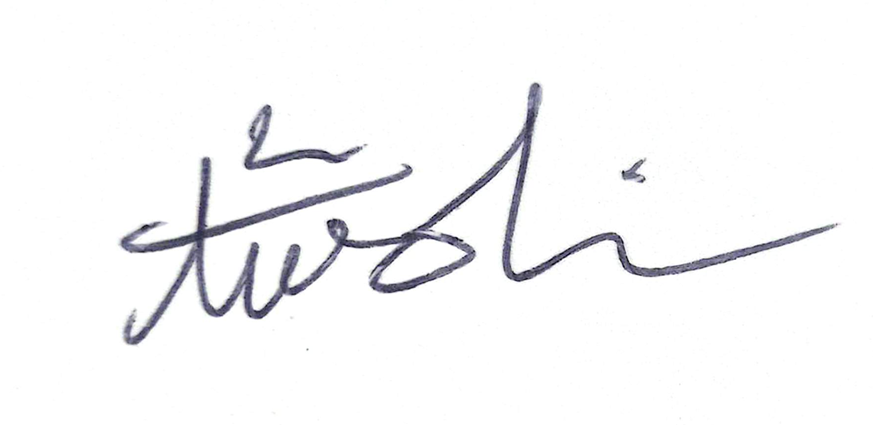
Date: 20th June 2026

